Test Case: tc001_SPX_Dev5_Crear_Requisicion_Spot_Tipo_Cobro_CC
Step 1 - Enter username and password and click to button Enter : Credentials Entered
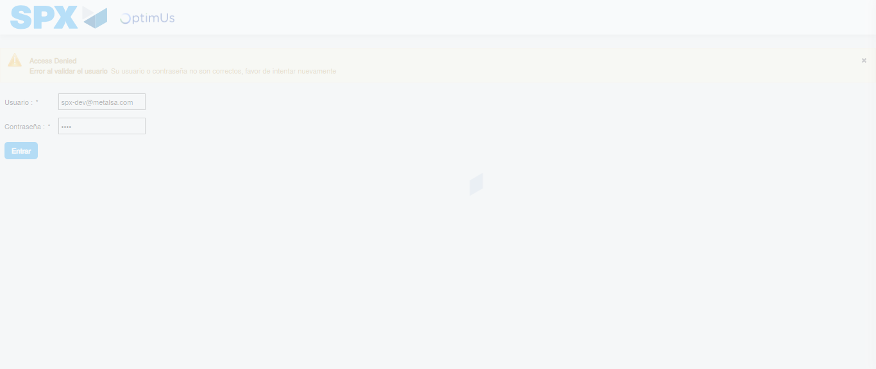Image file-name: QC_Testing-tc001_SPX_Dev5_Crear_Requisicion_Spot_Tipo_Cobro_CC-1789482402619

Step 2 - Select to UEN and Access to Spot Buy Requisitions : UEN Correctly selected and Correct access
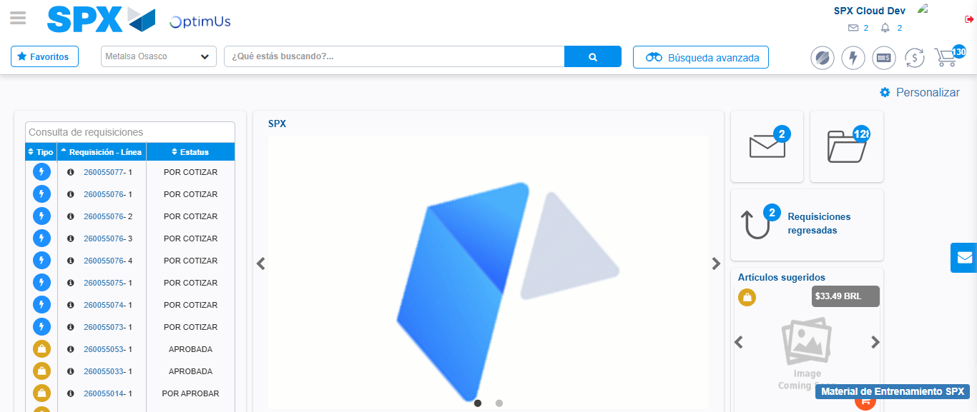Image file-name: QC_Testing-tc001_SPX_Dev5_Crear_Requisicion_Spot_Tipo_Cobro_CC-1789482425974

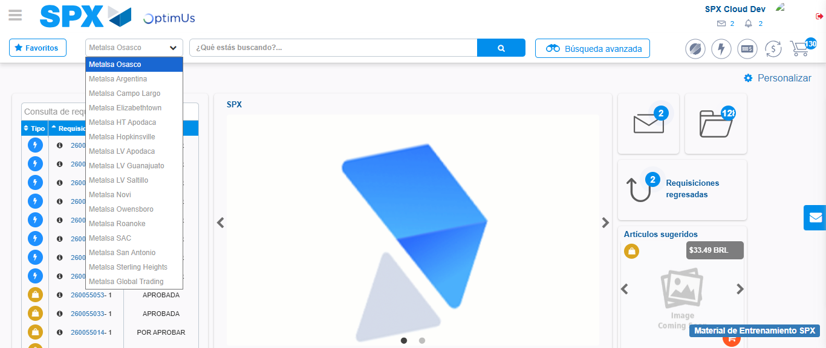Image file-name: QC_Testing-tc001_SPX_Dev5_Crear_Requisicion_Spot_Tipo_Cobro_CC-1789482426672

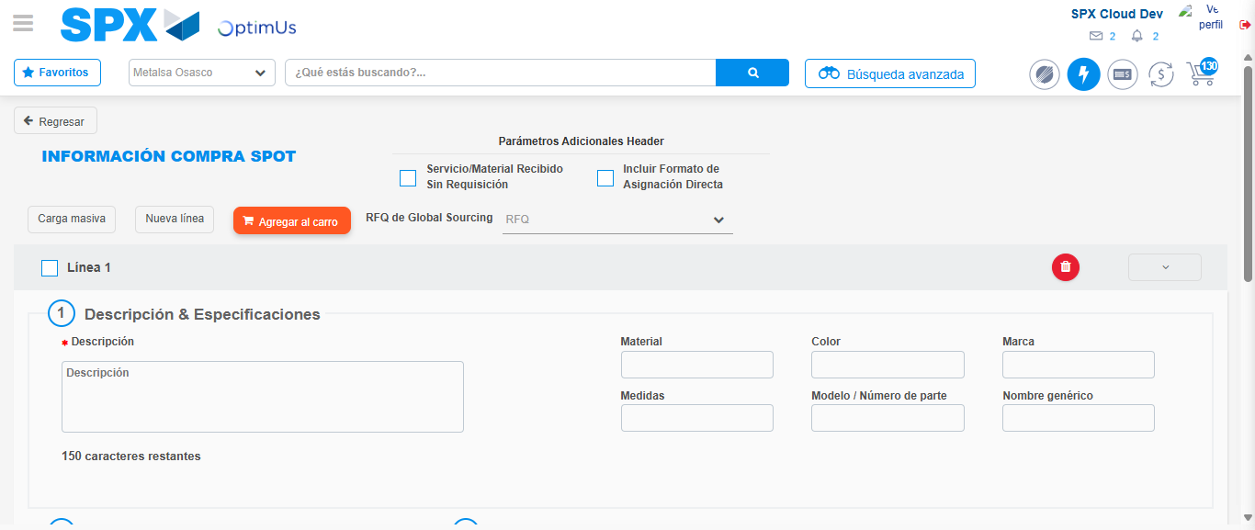Image file-name: QC_Testing-tc001_SPX_Dev5_Crear_Requisicion_Spot_Tipo_Cobro_CC-1789482431797

Step 3 - Data Capture Spot Buy Requisition : Data captured correctly
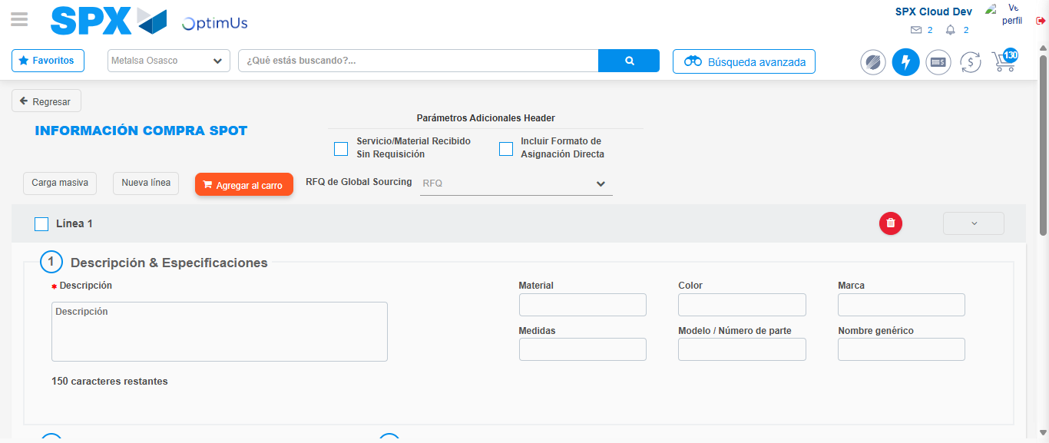Image file-name: QC_Testing-tc001_SPX_Dev5_Crear_Requisicion_Spot_Tipo_Cobro_CC-1789482432122

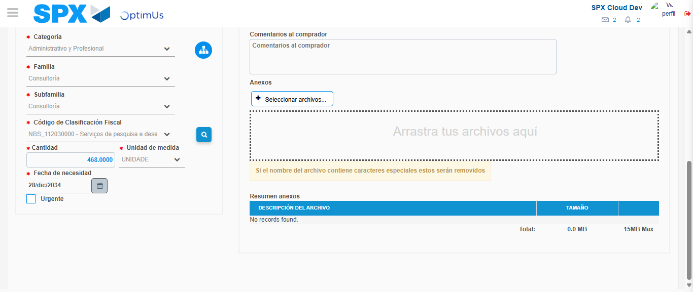Image file-name: QC_Testing-tc001_SPX_Dev5_Crear_Requisicion_Spot_Tipo_Cobro_CC-1789482449062

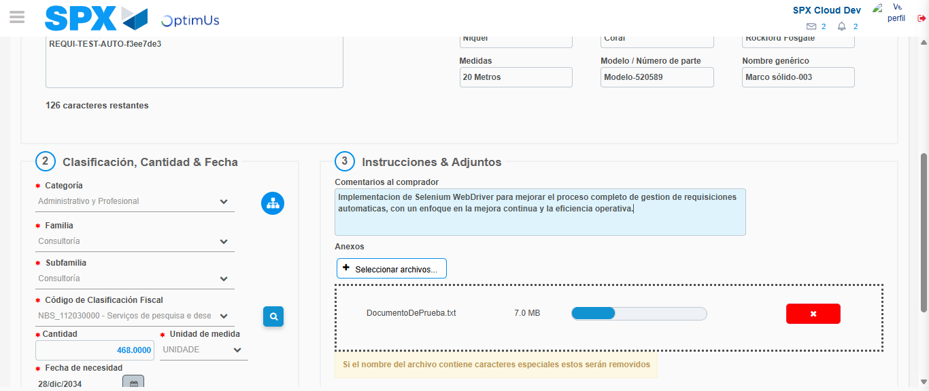Image file-name: QC_Testing-tc001_SPX_Dev5_Crear_Requisicion_Spot_Tipo_Cobro_CC-1789482450016

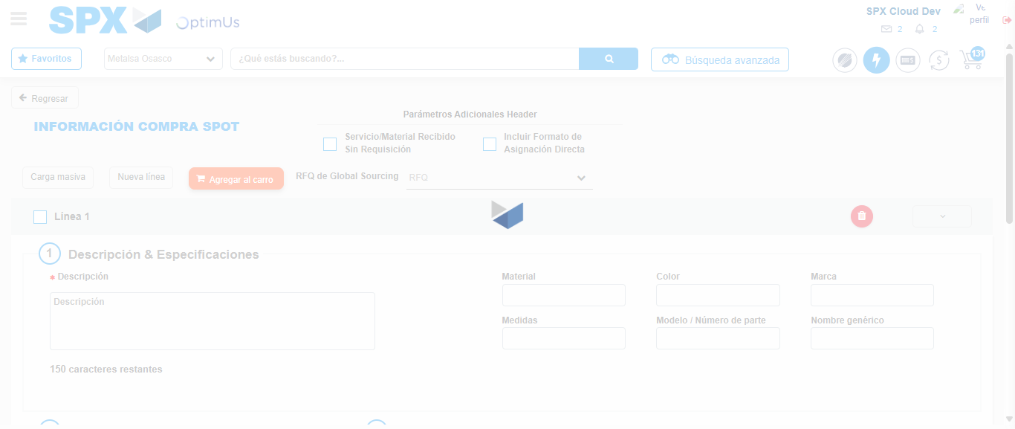Image file-name: QC_Testing-tc001_SPX_Dev5_Crear_Requisicion_Spot_Tipo_Cobro_CC-1789482451558

Step 7 - Return to Main Page SPX : Return to Main Page SPX
Image file-name: QC_Testing-tc001_SPX_Dev5_Crear_Requisicion_Spot_Tipo_Cobro_CC-1789482425974

Image file-name: QC_Testing-tc001_SPX_Dev5_Crear_Requisicion_Spot_Tipo_Cobro_CC-1789482426672

Image file-name: QC_Testing-tc001_SPX_Dev5_Crear_Requisicion_Spot_Tipo_Cobro_CC-1789482431797

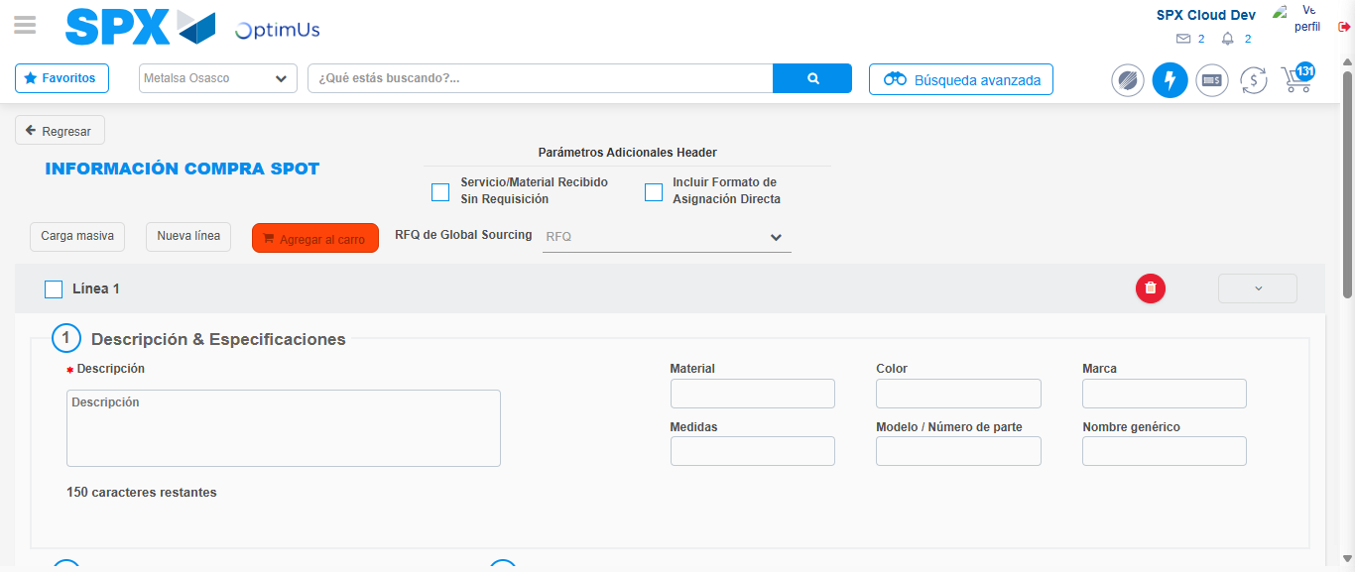Image file-name: QC_Testing-tc001_SPX_Dev5_Crear_Requisicion_Spot_Tipo_Cobro_CC-1789482453828

Image file-name: QC_Testing-tc001_SPX_Dev5_Crear_Requisicion_Spot_Tipo_Cobro_CC-1789482454004

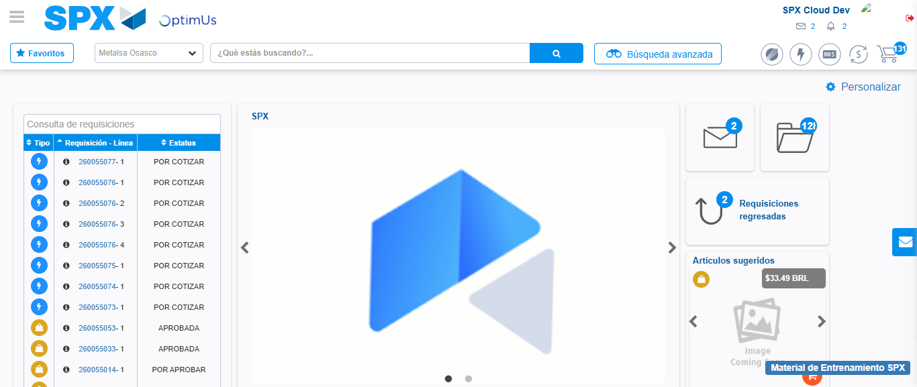Image file-name: QC_Testing-tc001_SPX_Dev5_Crear_Requisicion_Spot_Tipo_Cobro_CC-1789482475246

Step 8 - Log Out : Log Out SPX
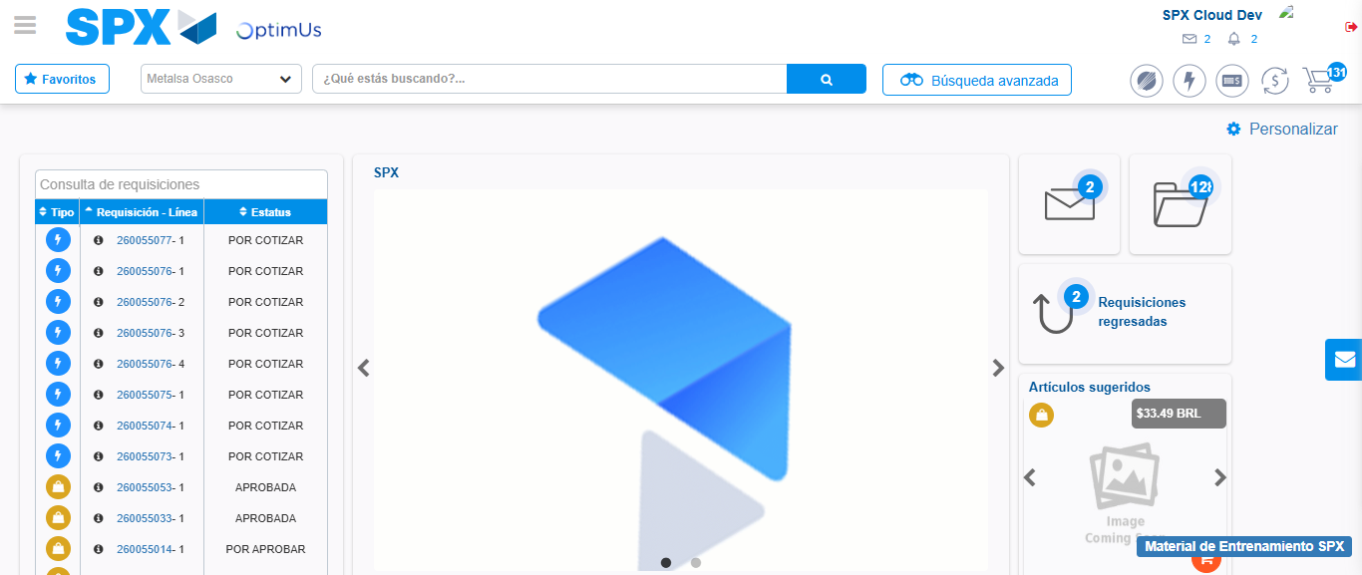Image file-name: QC_Testing-tc001_SPX_Dev5_Crear_Requisicion_Spot_Tipo_Cobro_CC-1789482475607

